Semester two Examination, 2019

Question/Answer booklet

MATHEMATICS SPECIALIST
UNITs 3 & 4

Section One:

Calculator-free

Your Name

Your Teacher’s Name

Time allowed for this section
Reading time before commencing work: five minutes
Working time: fifty minutes

Materials required/recommended for this section
To be provided by the supervisor
This Question/Answer booklet
Formula sheet

To be provided by the candidate
Standard items: pens (blue/black preferred), pencils (including coloured), sharpener, correction fluid/tape, eraser, ruler, highlighters

Special items: nil

Important note to candidates
No other items may be taken into the examination room. It is your responsibility to ensure that you do not have any unauthorised material. If you have any unauthorised material with you, hand it to the supervisor before reading any further.

Question | Mark | Max | Question | Mark | Max
1 |  | 6 | 5 |  | 9
2 |  | 6 | 6 |  | 7
3 |  | 12 | 7 |  | 5
4 |  | 6

Structure of this paper

Section | Number of questions available | Number of questions to be answered | Working time (minutes) | Marks available | Percentage of examination
Section One:  Calculator-free | 7 | 7 | 50 | 51 | 34
Section Two:  Calculator-assumed | 13 | 13 | 100 | 100 | 66
 |  |  |  | Total | 100

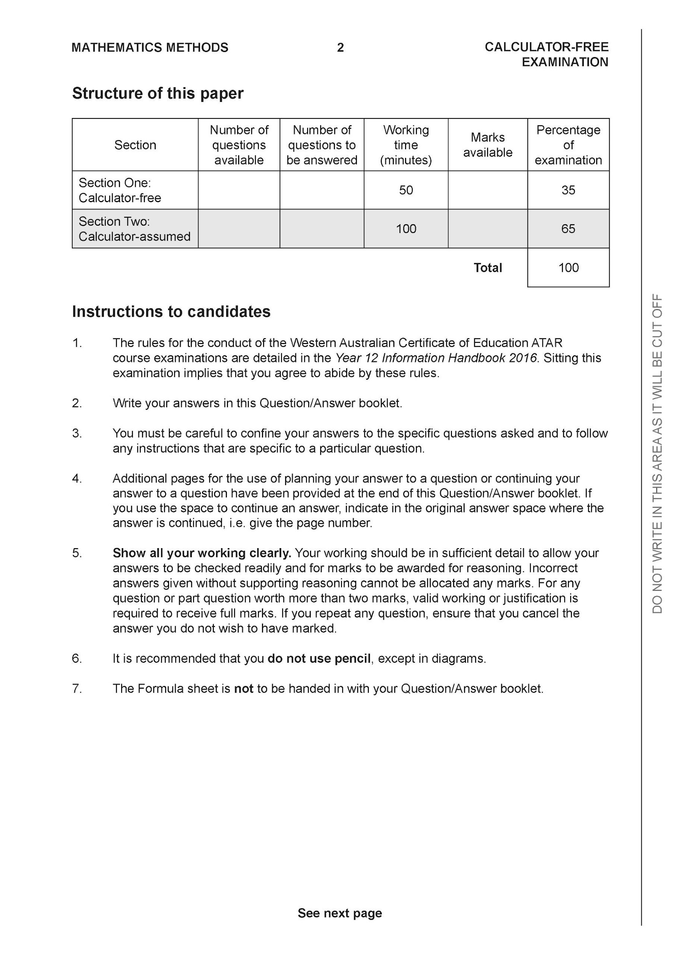

Section One: Calculator-free (51 Marks)

This section has seven (7) questions. Answer all questions. Write your answers in the spaces provided.

Spare pages are included at the end of this booklet. They can be used for planning your responses and/or as additional space if required to continue an answer.
● Planning: If you use the spare pages for planning, indicate this clearly at the top of the page.
● Continuing an answer: If you need to use the space to continue an answer, indicate in the original answer space where the answer is continued, i.e. give the page number. Fill in the number of the question that you are continuing to answer at the top of the page.

Working time: 50 minutes.

Question 1 (6 marks)

Let and .
Determine:
- the natural domain and range of . (2 marks)

Solution
Specific behaviours
✓ states domain
✓ states range

- (1 mark)

Solution
Specific behaviours
✓ states rule

- the natural domain and range of (3 marks)

Solution
Specific behaviours
✓ states natural domain with exclusion
✓ states range with exclusion with at least one correct endpoint of interval
✓states complete range

Question 2 (6 marks)

Consider the following system of linear equations.

- Solve for . (3marks)

Solution
Specific behaviours
✓ eliminates one variable
✓ eliminates two variables
✓solves for all variables

- For the following system where are constants, determine

the possible values of for i) no solutions
ii) infinite solutions. (3 marks)

Solution
Specific behaviours
✓ eliminates two variables
✓ states values for infinite
✓states values for no soln

Question 3 (12 marks)
Determine the following integrals.

- using (3 marks)

Solution
Specific behaviours
✓ changes variables
✓ integrates correctly
✓adds a constant and expresses in terms of x only

- (3 marks)
Solution
Specific behaviours
✓ uses double angle formula
✓ integrates all terms
✓solves for multiplied constant (no need for added constant)
- (3 marks)

Solution
Specific behaviours
✓ uses trig identity
✓ breaks into two integrals
✓solves for multiplied constants (no need for added constant)

d) (3 marks)
Solution
Specific behaviours
✓ uses tan function
✓ correct angle
✓solves for multiplied constant(no need for added constant)

Question 4 (6 marks)

- Express the following expression into partial fractions (3 marks)

Solution
Specific behaviours
✓ uses three fractions
✓ solves for one constant
✓solves for all constants

- Hence evaluate (Do not simplify) (3 marks)
Solution
Specific behaviours
✓ uses ln function for two fractions
✓ integrates all terms correctly
✓obtains un-simplified expression for definite integral
Question 5 (9 marks)

Consider a plane that contains the following points, .

- Determine a vector equation for all points in the plane above. (3 marks)

Solution
Specific behaviours
✓ determines two vectors in plane
✓ uses cross product to find normal
✓determines vector equation of plane

- Determine the distance of point from the plane in part a. (3 marks)
(Do not simplify)

Solution
Specific behaviours
✓ finds vector from D to point in plane
✓ uses dot product with unit normal vector
✓obtains un-simplified expression for distance

- Determine the cosine of the angle that the line makes with the plane in . (3 marks)

Solution
Specific behaviours
✓ uses dot product
✓ obtains cosine of angle between line and normal (plus or minus)
✓obtains cosine of angle with plane

Question 6 (7 marks)

Consider the logistical model defined by where are positive constants.
- Determine the value of , ,where . Explain the significance of this value.
(2 marks)

Solution
Limiting value
Specific behaviours
✓ states value of N
✓ states limiting value

- Derive the logistical formula showing steps in your working. (5 marks)
Solution
Specific behaviours
✓ uses separation of variables method
✓ uses partial fractions and shows derivation of constants
✓ integrates partial fractions using ln(absolute value)
✓explains why absolute value not needed
✓derives required solution function

Question 7 (5 marks)

Evaluate the following integral showing all working.(Simplify)

Solution
Specific behaviours
✓ uses cosine double angle formula at least once
✓ expands binomial terms and uses double angle formula again
✓ integrates terms correctly
✓subs limits into integration and obtains un-simplified expression
✓obtains simplified two terms(no need to factorise)
Due to complexity- follow through will only occur if solution is not made easier

End of section one

Acknowledgements

